**Code Example 1: Role of feedback in closed-loop dynamical systems**

**Code:** example_1.py

**Code description:**

We use **scipy.integrate.odeint** to solve the system's differential equations numerically over a time interval from 0 to 10 seconds.

**Positive feedback**: The state x(t) will tend to grow over time because the feedback amplifies the state. If the system's decay is not strong enough, the state will increase exponentially.

**Negative feedback**: The state x(t) will decay over time as the feedback stabilizes the system. The state will eventually reach a steady state (possibly 0 if a and b are balanced properly).

**Code Example 2: Simple temperature dynamics model**

**Code:** example_2.py

**Code description:**

We will simulate heat loss to the environment according to Newton's Law of Cooling.

<https://en.wikipedia.org/wiki/Newton's_law_of_cooling>

This results in a simple first order linear ordinary differential equation in the form:

This ODE model of the heat transfer is also referred to as Resistance-Capacitance (RC) models. It is based on an electrical analogy, where:

* Thermal resistance (R) is analogous to electrical resistance, representing insulation or heat loss pathways.
* Thermal capacitance (C) is analogous to electrical capacitance, representing the ability of a system to store heat energy.
* Temperature difference is analogous to voltage difference in electrical circuits.

**Code Example 3: Rule-based control of a simple temperature dynamics model**

**Code:** example_3.py

**Code description:**

Given the ODE system from the example 2, we include a relay thermostat controller that turns the heater ON when the temperature drops below a lower threshold and OFF when it exceeds an upper threshold. This models a basic bang-bang (hysteresis) control system commonly used in home thermostats.

<https://en.wikipedia.org/wiki/Bang%E2%80%93bang_control>

The modified ODE model now includes the external heating source *P*source.

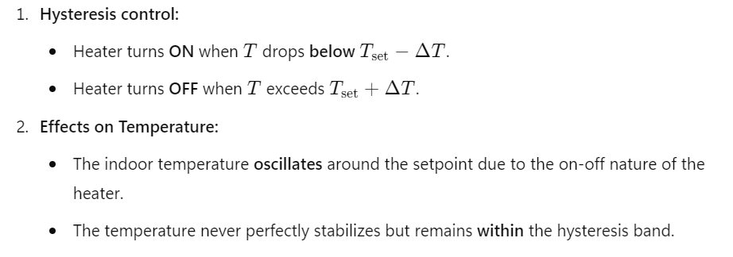

**Code Example 4: PID control of a simple mass-spring-damper system**

**Code:** example_4.py

**Code description:**

To demonstrate PID control of a simple ODE system, let's consider a system that represents a first-order differential equation, such as a mass-spring-damper system. We will apply a PID controller to regulate the position of the mass to a setpoint.

The PID control algorithm uses three components to compute the control signal (force or input) based on the error between the desired setpoint and the current measured value. The three components are **Proportional (P)**, **Integral (I)**, and **Derivative (D)**.

Play with the PID coefficients to investigate its effect on the system dynamics.

